# CLIENT INTERFACE - WEB DESIGN

The client interface should have the following information:

1. **Client’s Details  
   Your Details**
2. First Name
3. Last Name
4. Email Address
5. Mobile
6. Telephone
7. Work Phone
8. Alternative Email
9. House Number & Street
10. City
11. State
12. Country
13. Postcode/Zip
14. Preferred Contact (Email, Mobile, Telephone, Work Phone)
15. Signed Up (Date)
16. **Dog’s Details**. Clients can have multiple dogs so they will need to be able to ‘Add A Dog’.

**Dog Details**  
a. Dog’s Name  
b. Gender (Male, Male Neutered, Female, Female Spayed)  
c. D.O.B.  
d. Age  
e. Allergies  
f. Primary Breed  
g. Secondary Breed  
h. Deceased (Tick Box)  
i. Deceased Date (Date Field)

1. **Client Profile Form** (as shared previously)
2. **Client’s Family Details.** In this section the client can add details of additional family members, including spouse, children, parents, housemates and other (non-dog) pets. Clients will be able to add the following details themselves.   
   Your Family  
   Help us get to know your family by filling in the following fields. Note: If family members are not added here only your name will appear on graduation certificates.
   1. Family Member’s Name
   2. Family Member’s Age
   3. Family Member’s Sex
   4. Relationship to Client
3. **Upload Client Profile Photo** - Clients can upload their own profile picture.
4. **Upload Dog Photo** (for each dog). If no image is uploaded a default image will display, see below:



1. **Current & Upcoming Courses & Services**, for example:  
     
   **Essential Puppy School II   
     
   What To Bring**  
   Current Vaccination Certificate  
   Treats  
   Mat  
   Collar (Buckle or Snap-lock only)  
   Leash (No Retractable or Elasticated Leashes)  
   Your Puppy’s Crate  
   Closed In Shoes  
     
   **Scheduled:**   
   **Week 1:** Monday 28th August 2017 - 6:00pm - 7:00pm   
   **Week 2:** Monday 4th September 2017 - 6:00pm - 7:00pm

**Week 3:** Monday 11th September 2017 - 6:00pm - 7:00pm   
 **Week 4:** Monday 18th September 2017 - 6:00pm - 7:00pm   
 **Week 5:** Monday 25th September 2017 - 6:00pm - 7:00pm   
 **Week 6:** Monday 2nd October 2017 - 6:00pm - 7:00pm  
   
 **Adolescent Play Group  
 What To Bring** CurrentPlay Group Card  
 Treats  
 Closed-In Shoes  
 **Scheduled:**  
 Sunday 3rd September 2017 - 12:00pm - 1:00pm  
   
 **Private Lesson - Rover  
 What To Bring** Collar (Buckle or Snap-lock)  
 Leash (No Retractable, Chain or Elasticated Leashes)  
 Treats (Soft Human-Food Treats) **Scheduled:**  
 Tuesday 19th September - 4:00pm - 5:00pm

1. **Past Courses & Services  
     
   Rover** (Dog)  
   **Essential Puppy School I** - Graduated Monday 7th August 2017 **Adolescent Play Group** - Completed Sunday 30th July 2017  **Adolescent Play Group** - Completed Sunday 23rd July 2017   
   **Seminar - Play With Your Dog** - Completed Wednesday 19th July 2017 **Adolescent Play Group** - Completed Sunday 16th July 2017  
   **Puppy Play Group** - Completed Sunday 9th July 2017  
   **Free Puppy Pre-School** - Graduated Wednesday 5th July 2017  
   **Play Group Orientation** - Completed Sunday 2nd July 2017  
     
   **Fido** (Dog)  
   **Essential Dog Training** - Graduated Saturday 12th July 2016
2. **VIP STATUS & Package Information** - should include Purchase Date, Package Name, Dog Name, Available Credits, Description of What Credits Are Valid For (i.e. Course/Service/Event Name), Used Credits, Package Expiry Date, Cost, Installments (including installment due dates). **Note:** One (or more) credit can be valid for multiple courses/services i.e. Clients can have one credit that can be used on any one of 6 (or more) potential courses.
3. **Your Documents -** This will be documents that are provided to clients as part of the course or service they’re enrolled in (including seminars, private lessons, workshops, etc.). These documents can be supplied in several formats but will mostly be PDFs and JPEGs. Clients should be able to view, print and download their documents.   
     
   Here is a flowchart that outlines how the ‘My Documents’ will work:  
   <https://www.lucidchart.com/invitations/accept/7142b0c2-7a24-4c6f-bc59-4739e51100da>   
     
   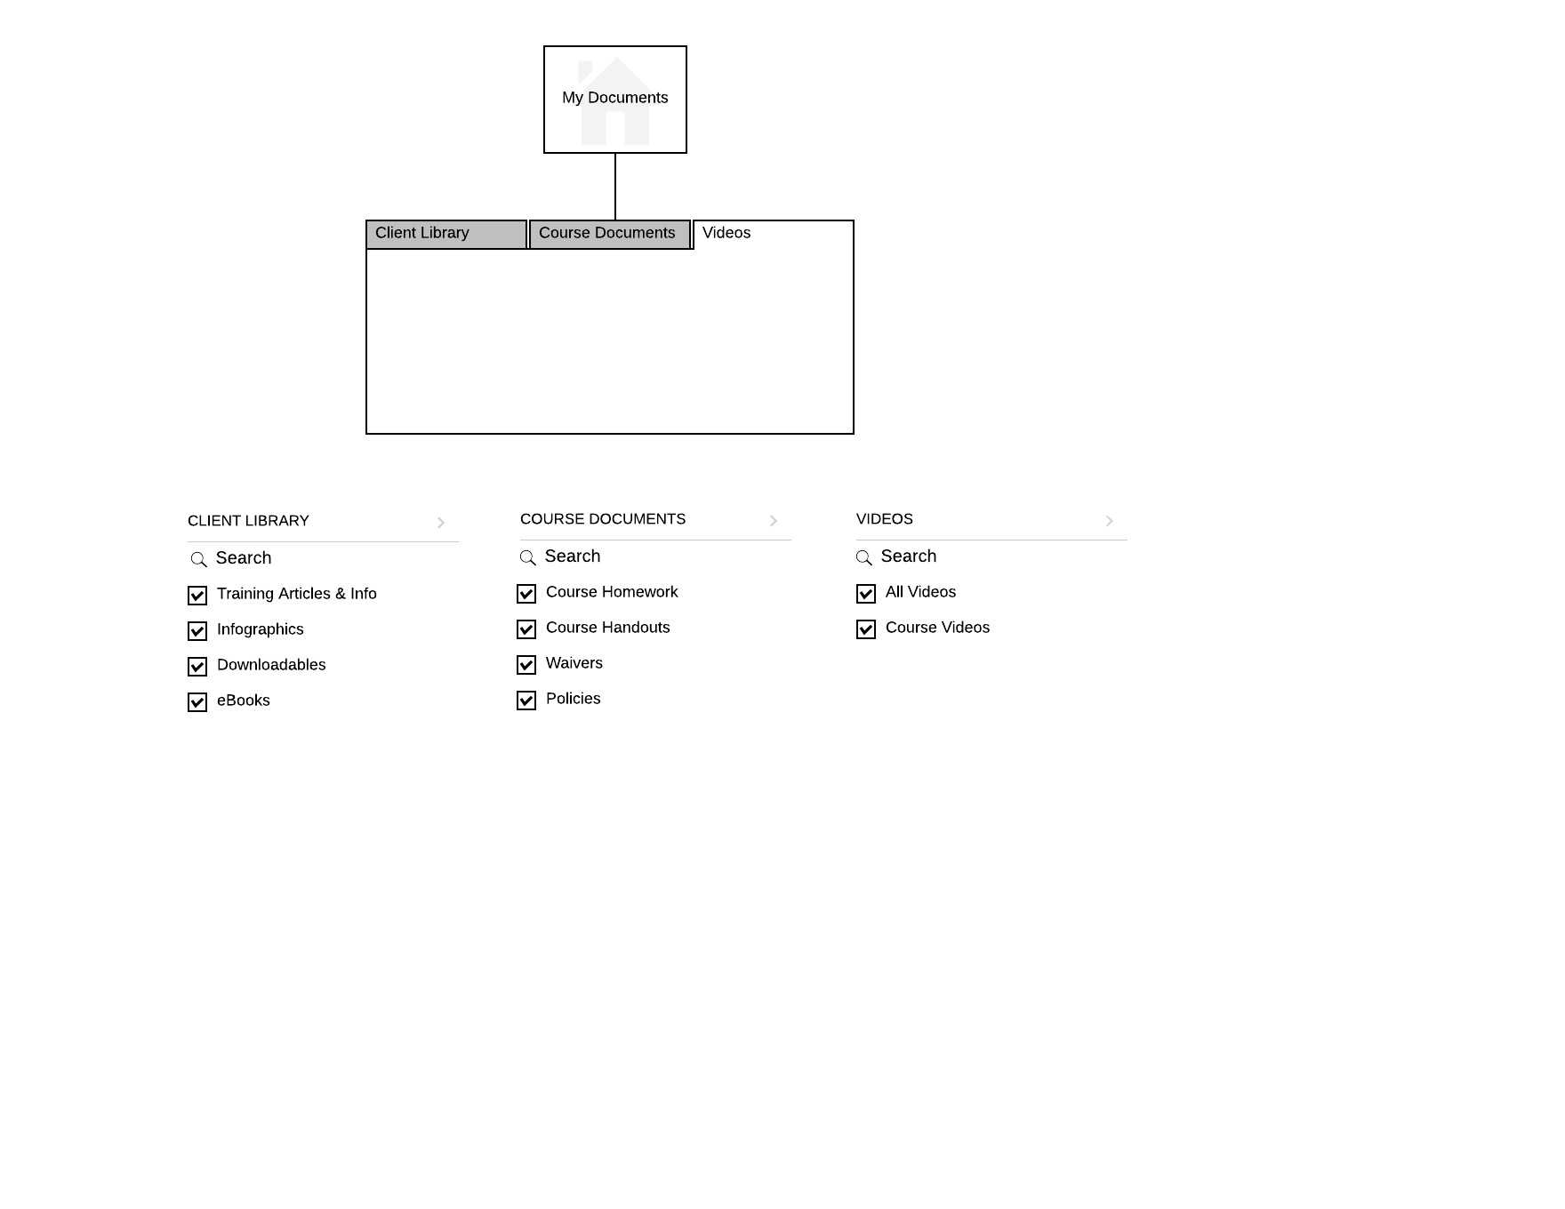  
     
   Here is a flowchart outlining the file types in the ‘My Documents’ section:  
   <https://www.lucidchart.com/invitations/accept/788c3138-835e-461b-b71f-663cfda62e5d>
4. **Your Videos** - This will be videos that are provided to clients as part of the course or service they’re enrolled in (including seminars, private lessons, workshops, etc.). These videos can be supplied in several formats but will mostly be MOVs or MP4s. Clients should be able to watch their videos when logged in. A third-party video player will be integrated.
5. **Reminders** - these are reminders that should be obvious to clients when logging into their account. Admin can set reminders to appear on client accounts. For example, a client may login and have a reminder to bring items to class, or that we have cancelled classes due to bad weather, public holiday closures, etc.
6. **Get Directions** - Clients can get directions to our venue via Maps in-built into our system.
7. **Change Password** - we assume clients should have the ability to change their password in their account.
8. **Waivers** - Clients should be able to view/print any/all waivers they’ve signed with us.
9. **Enrol into a Course** **or Event** - clients should be able to enrol any of their dogs into a course.
10. **Schedule Private Training** - Clients should be able to book a Behavioural Consultation, Private Lesson or Telephone Consultation.
11. **Purchase A Package** - Clients should be able to buy a package.
12. **Contact Us** - Clients should be able to contact us via their profile by pressing a button.
13. **View/Update Profile** - Clients should be able to update their profile information at anytime when logged in.
14. **Access Client Library** - Clients should be able to view/download/print documents from our client library.